I am going to The Corner

A social story

Using this social story
You can read this story before you come to The Corner.
It will tell you what you might see, hear or feel.
This story is for everyone.
It might not cover all you need it to.
You can create your own story too.
If you need to, you can call or email State Library of Queensland to ask questions.
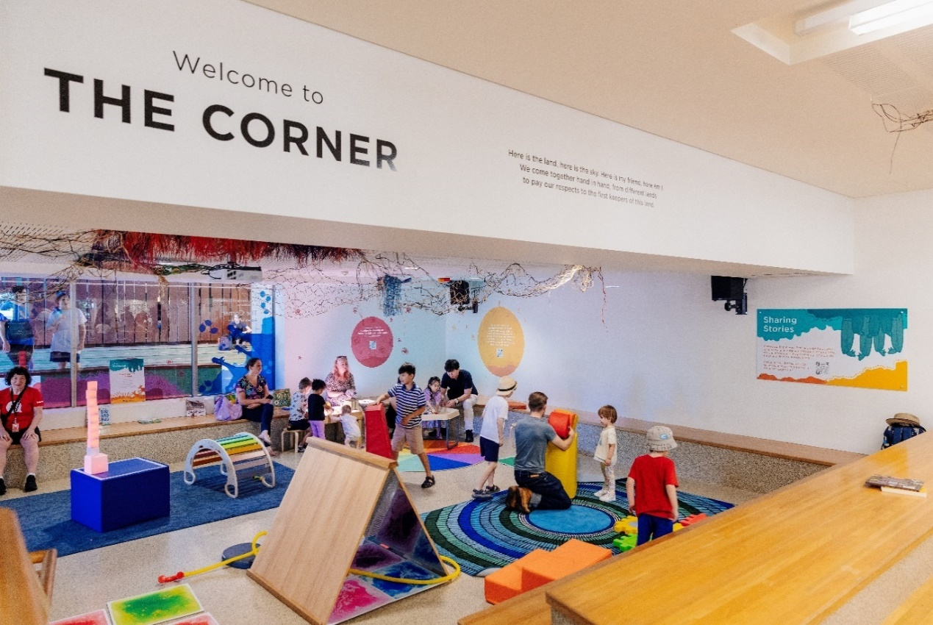

Today, I am going to The Corner!
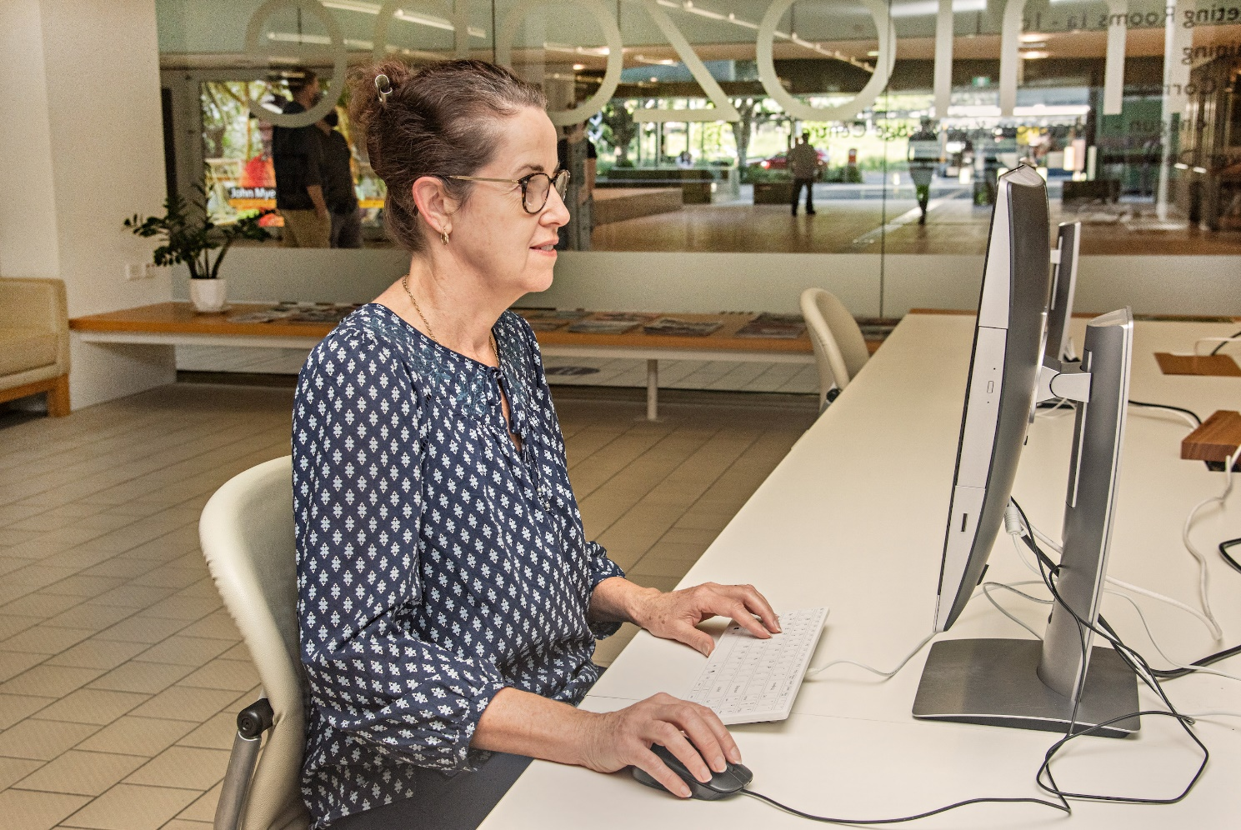

I go through the Infozone.
There are lots of people on computers here!
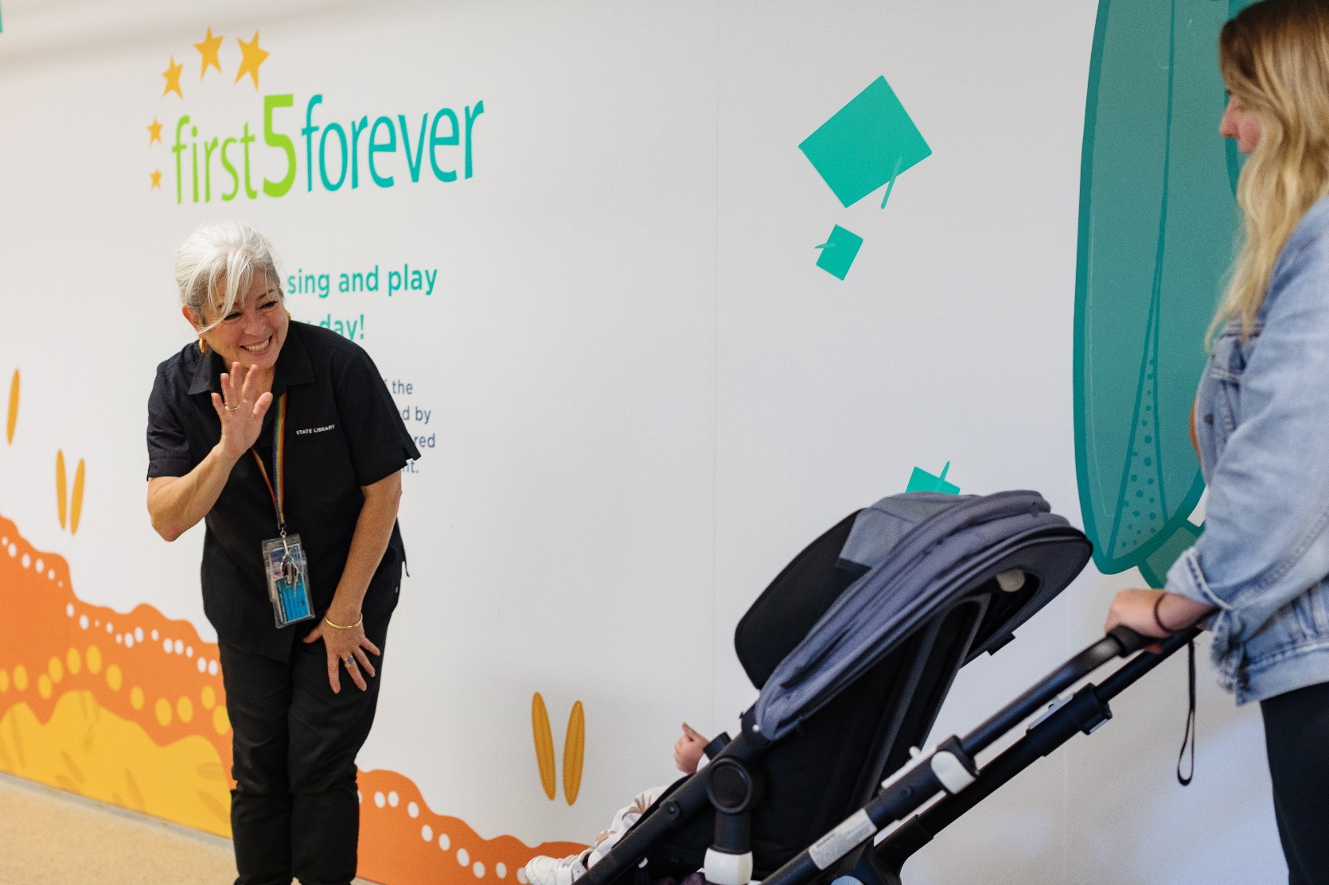

I can wave hello to State Library staff.
They wear black shirts and rainbow lanyards.

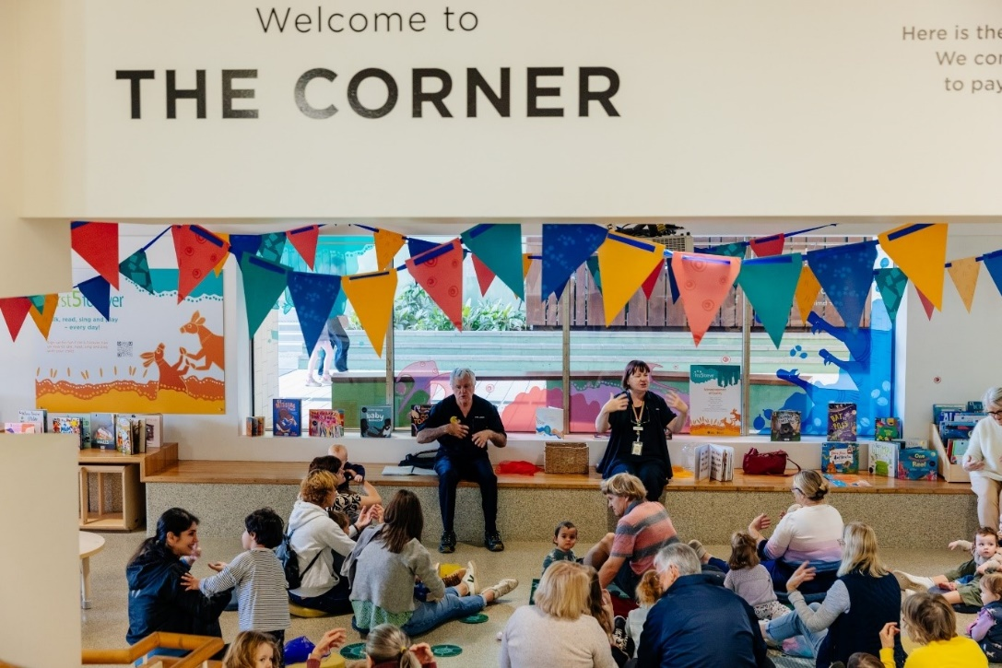
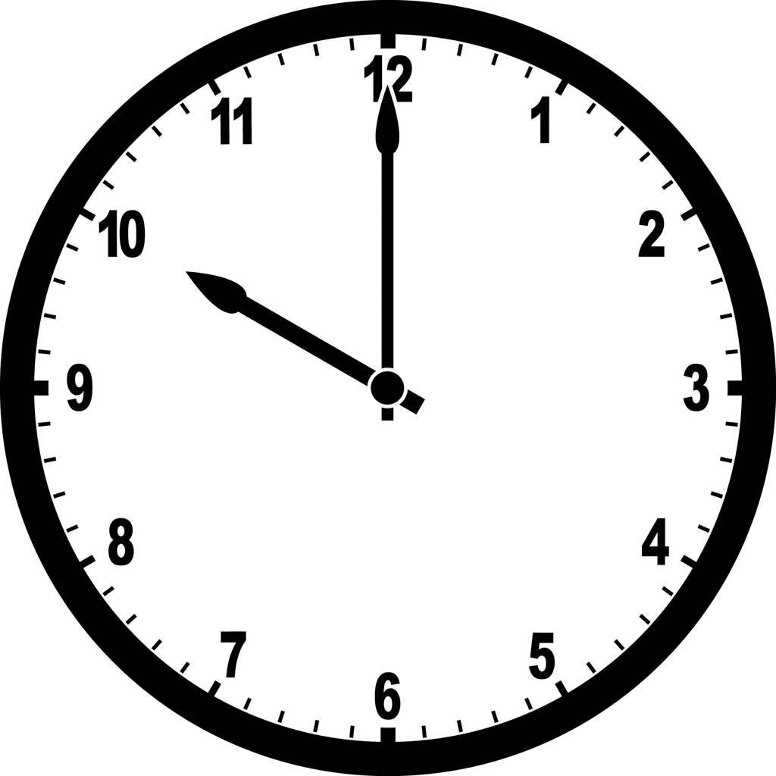

It is 10am. I can sit on a rug or a cushion.
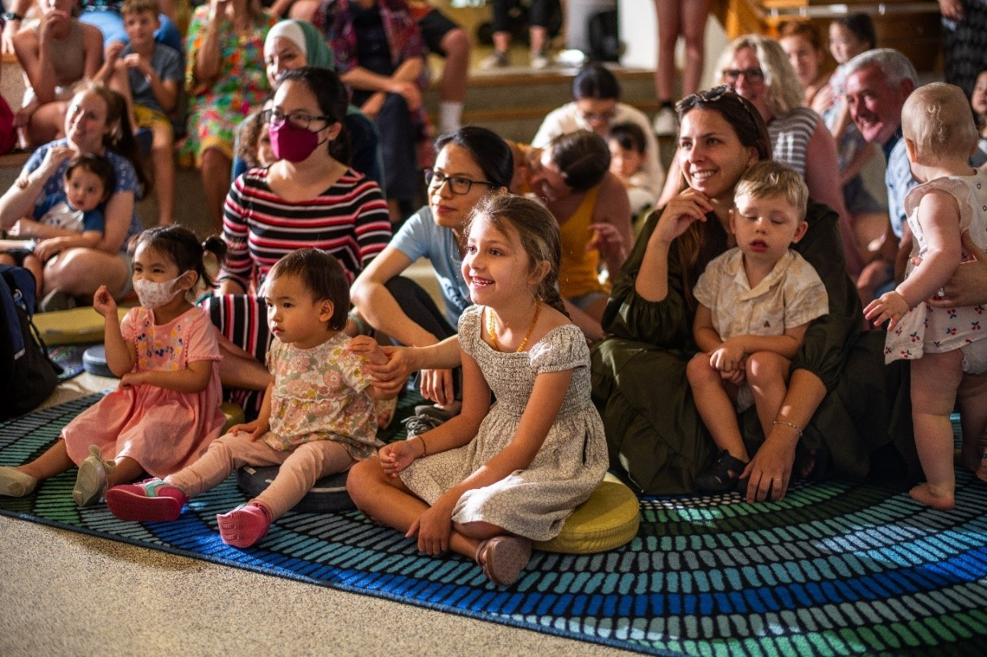

There are other people next to me. I might not know them.
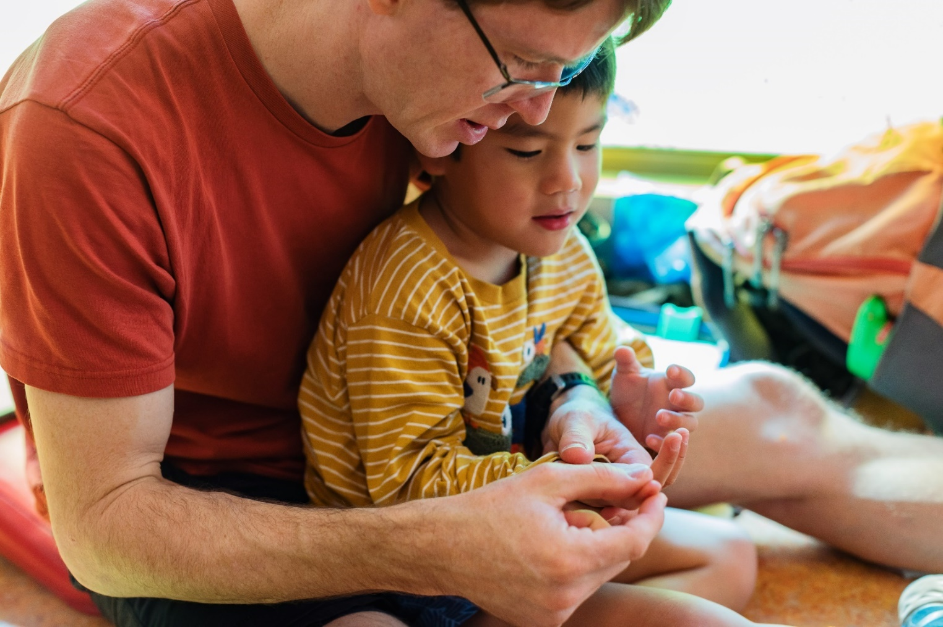
It is okay if I feel crowded. I can ask my adult to help me find more space.
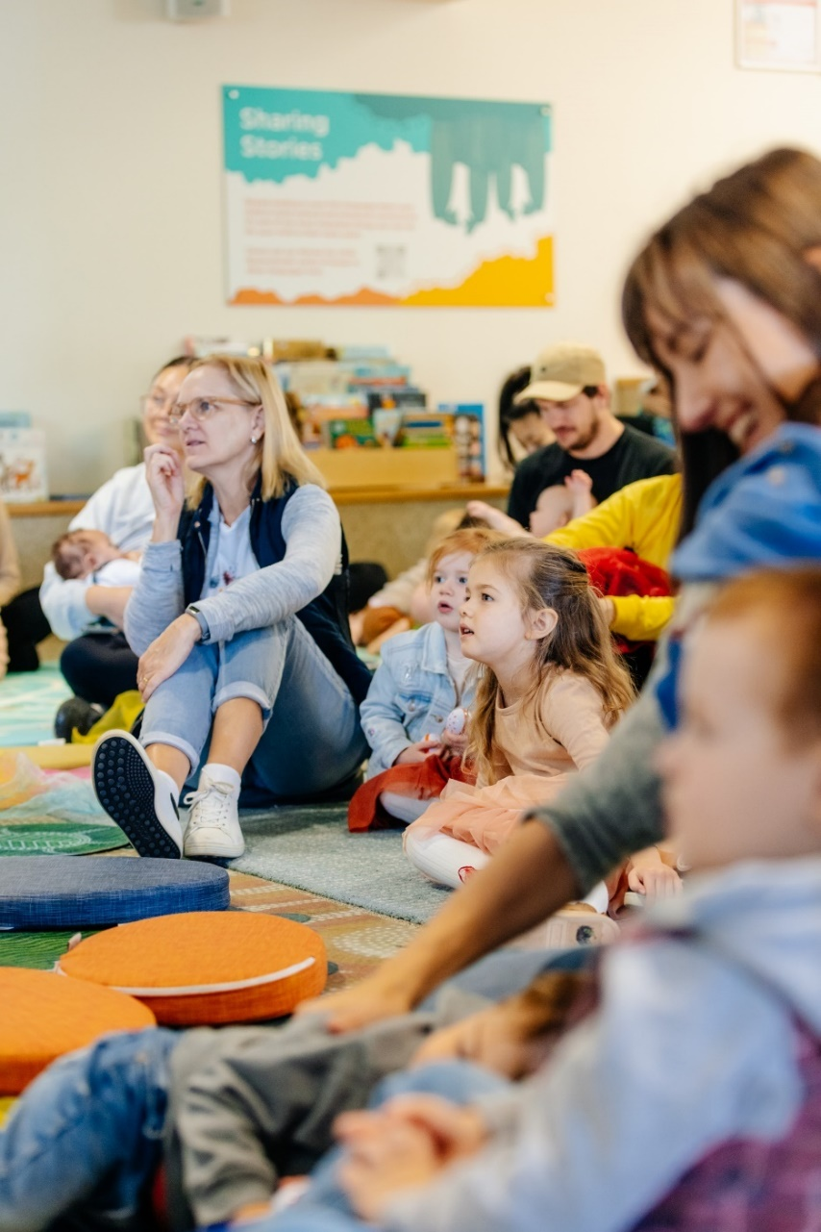
Everyone is waiting. Soon the staff will greet us.

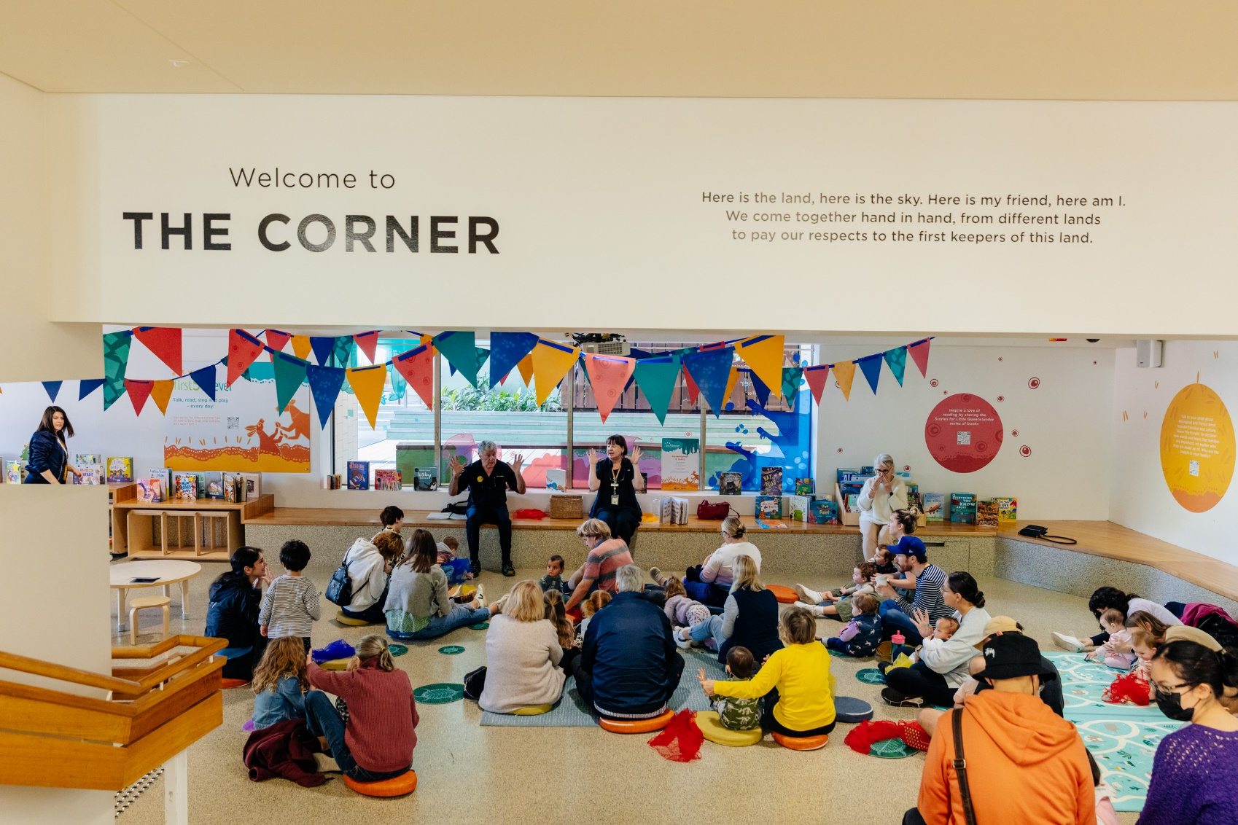
I hear the Hello Song. I can sing along.
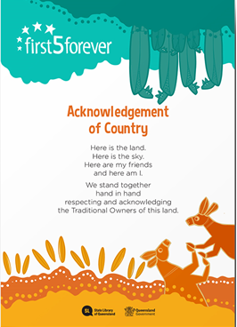

We acknowledge the Country we are on.
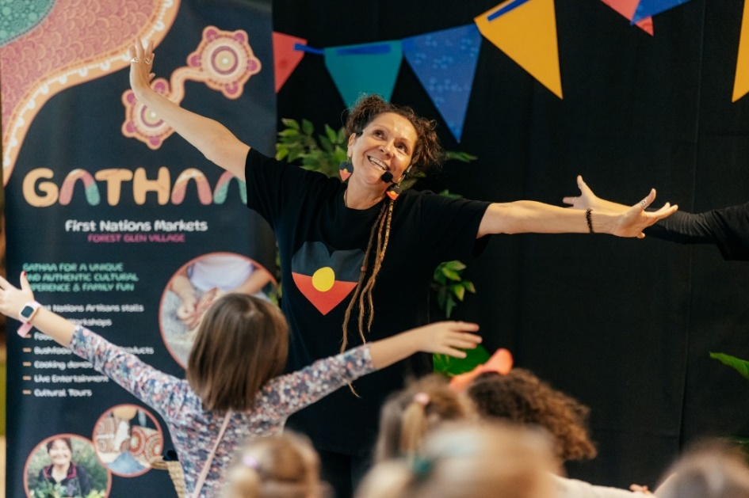
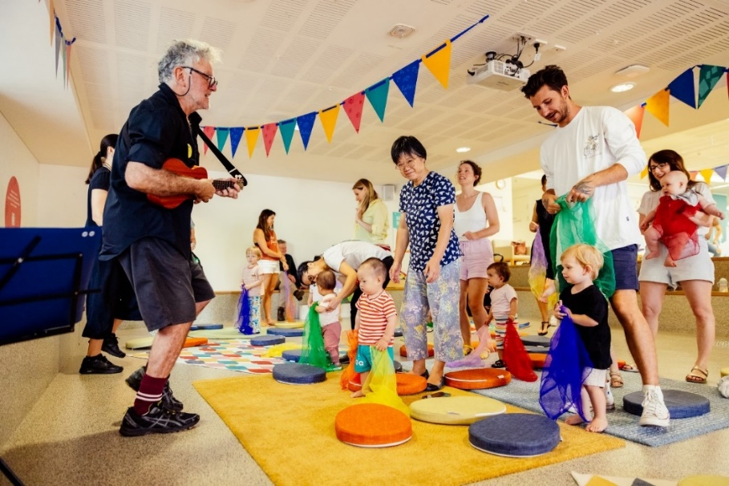

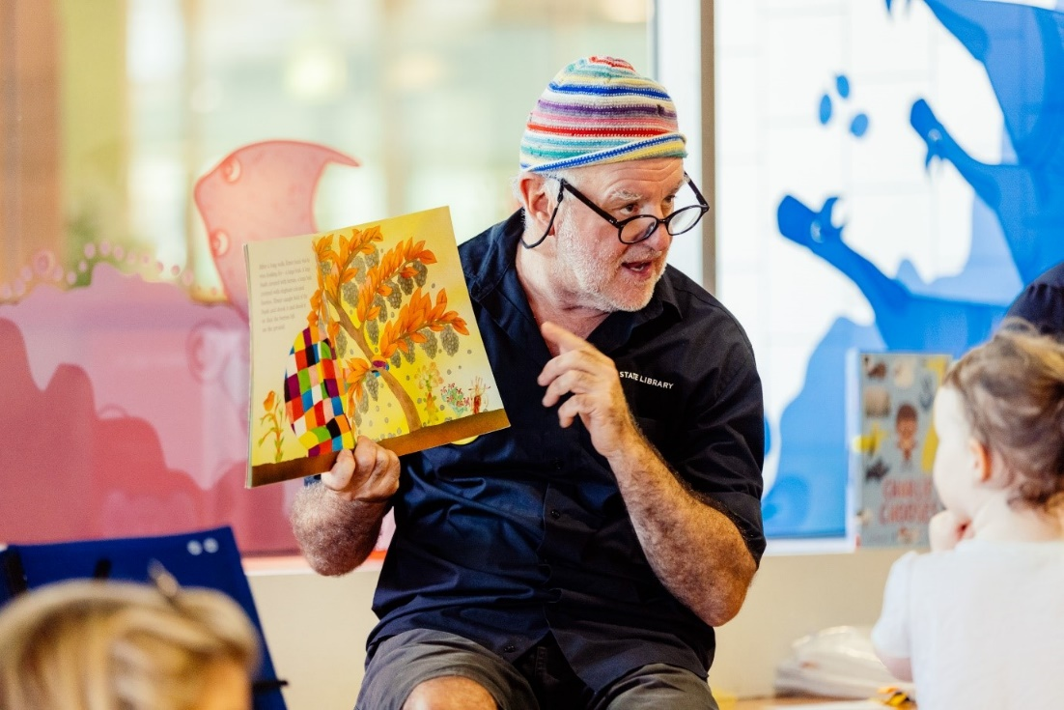
We sing, dance and read.

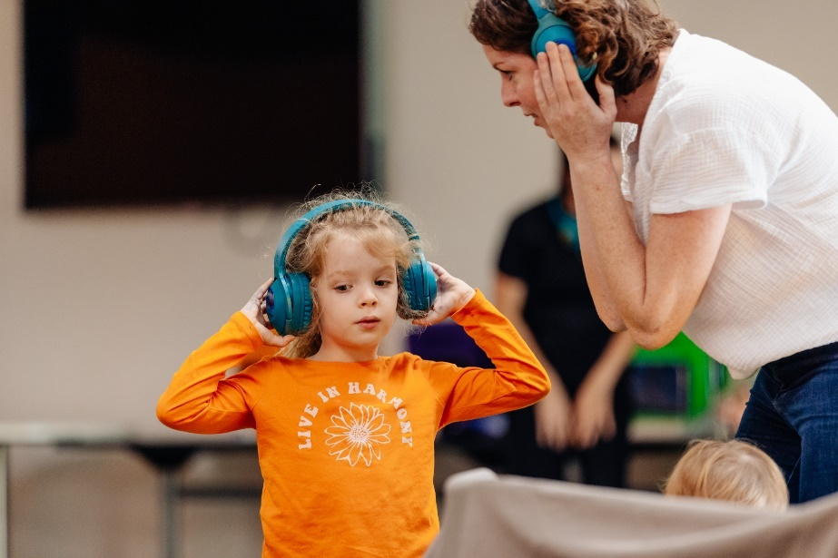


It might be loud. I can wear headphones.

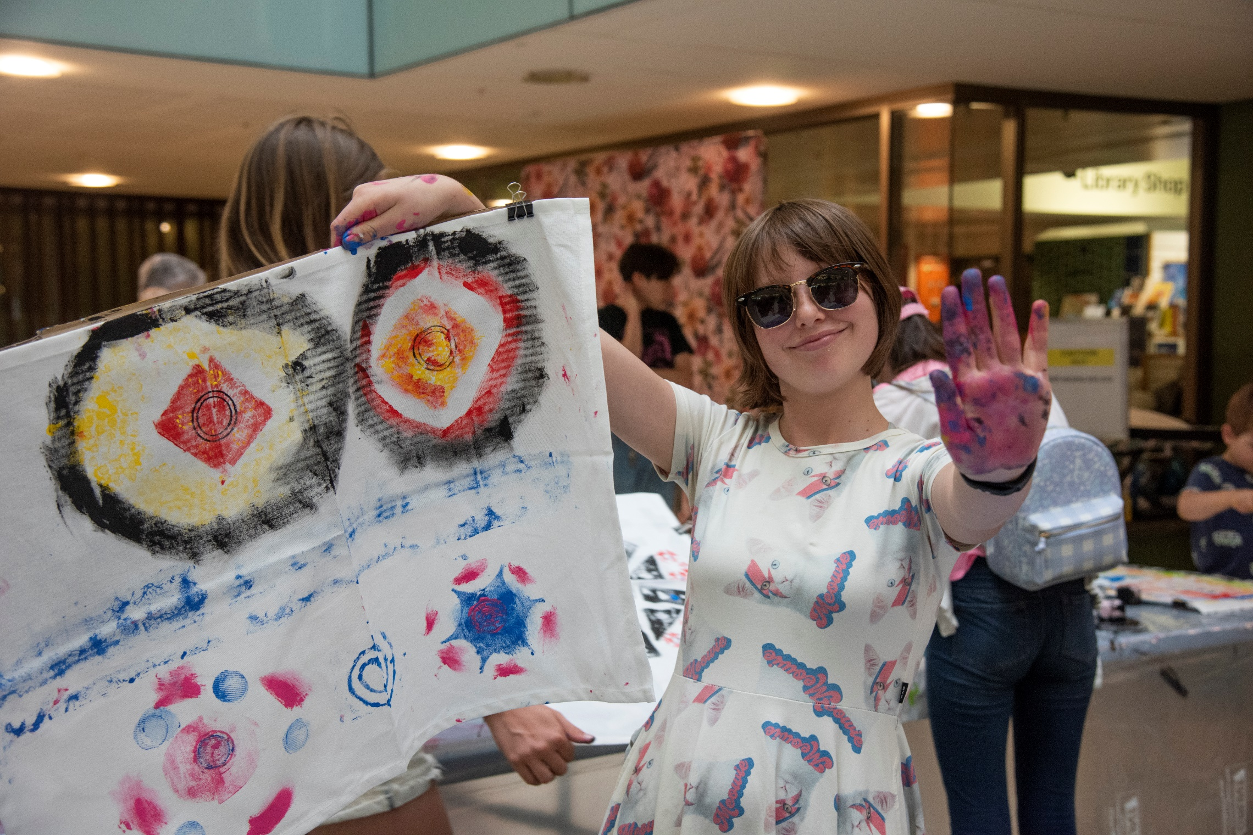

It might be bright. I can wear sunglasses.
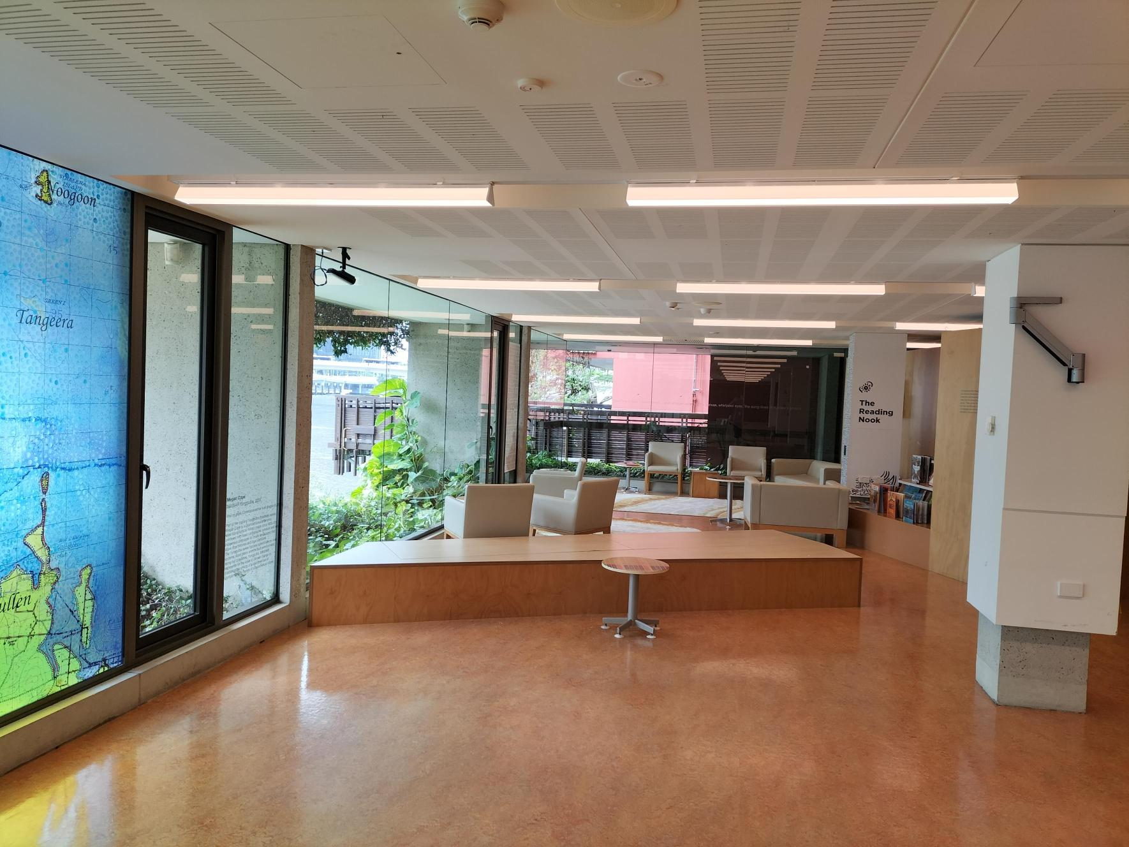

I can move to a quiet space. kuril dhagun is quiet.
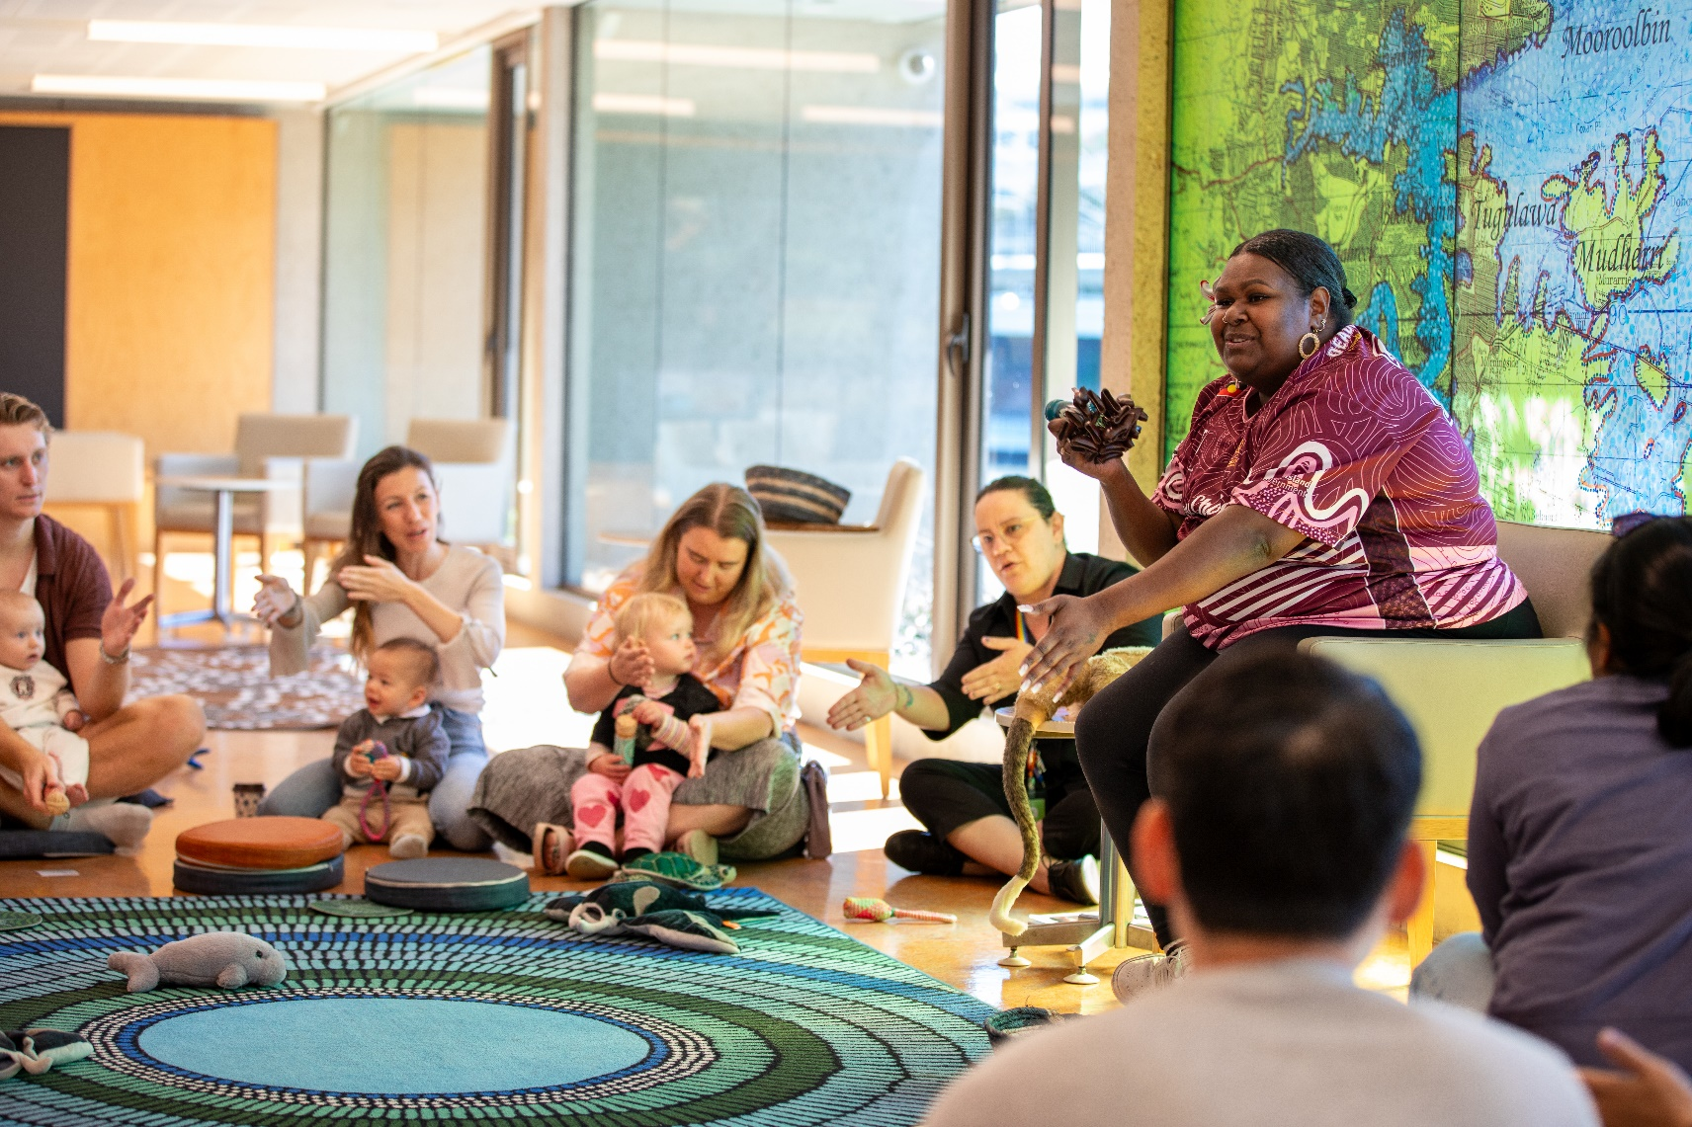

On Wednesdays we sing in kuril dhagun.

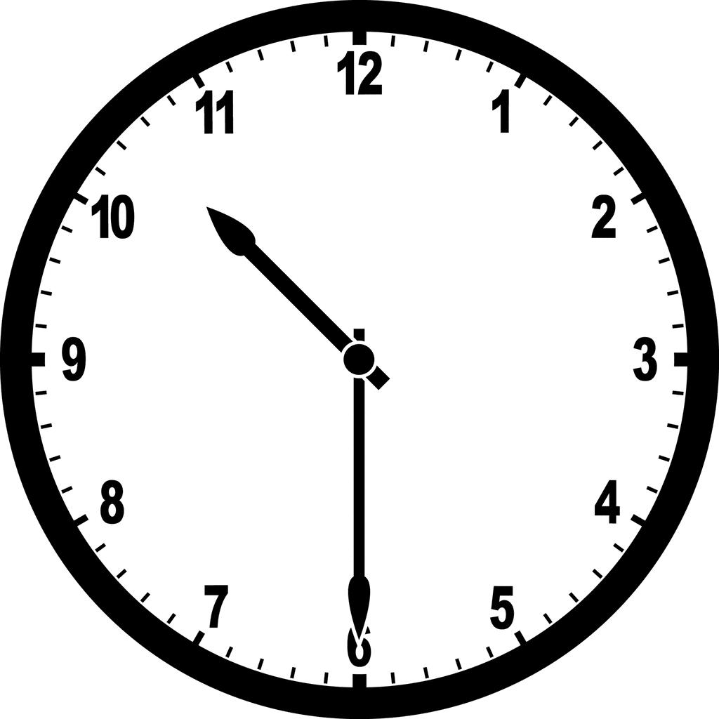
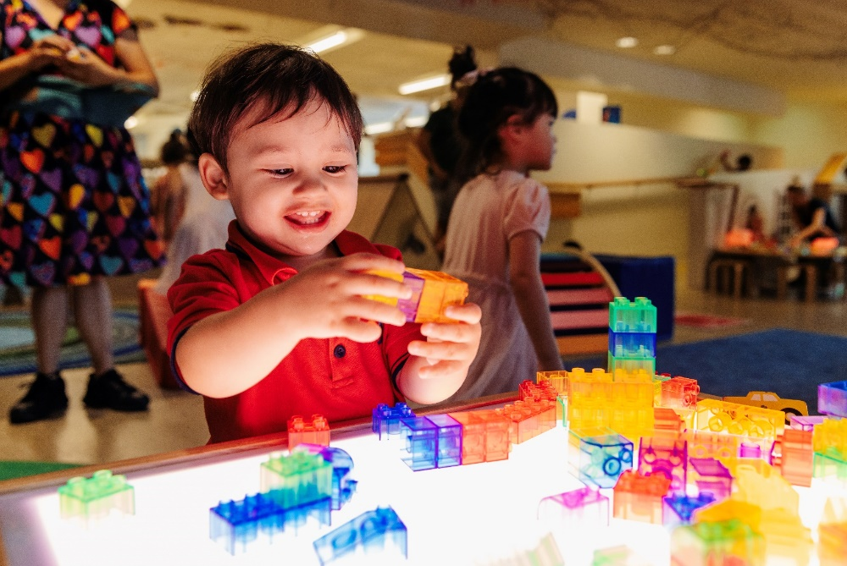

It is 10.30am. It is play time!


I can play.
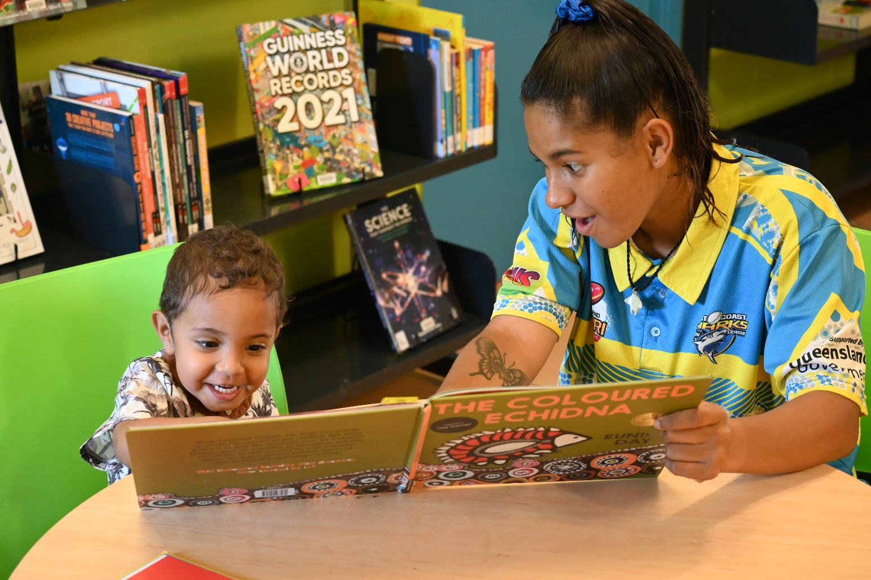

I can read.
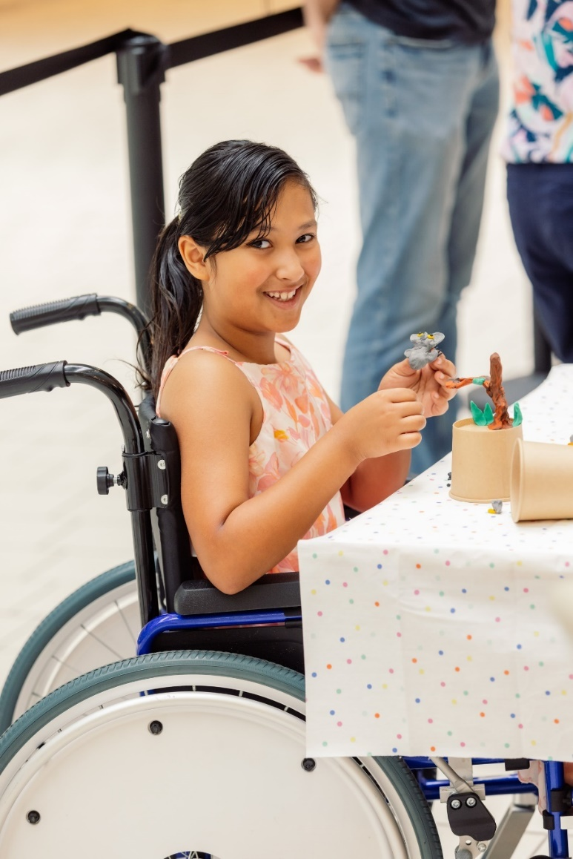

I can make.

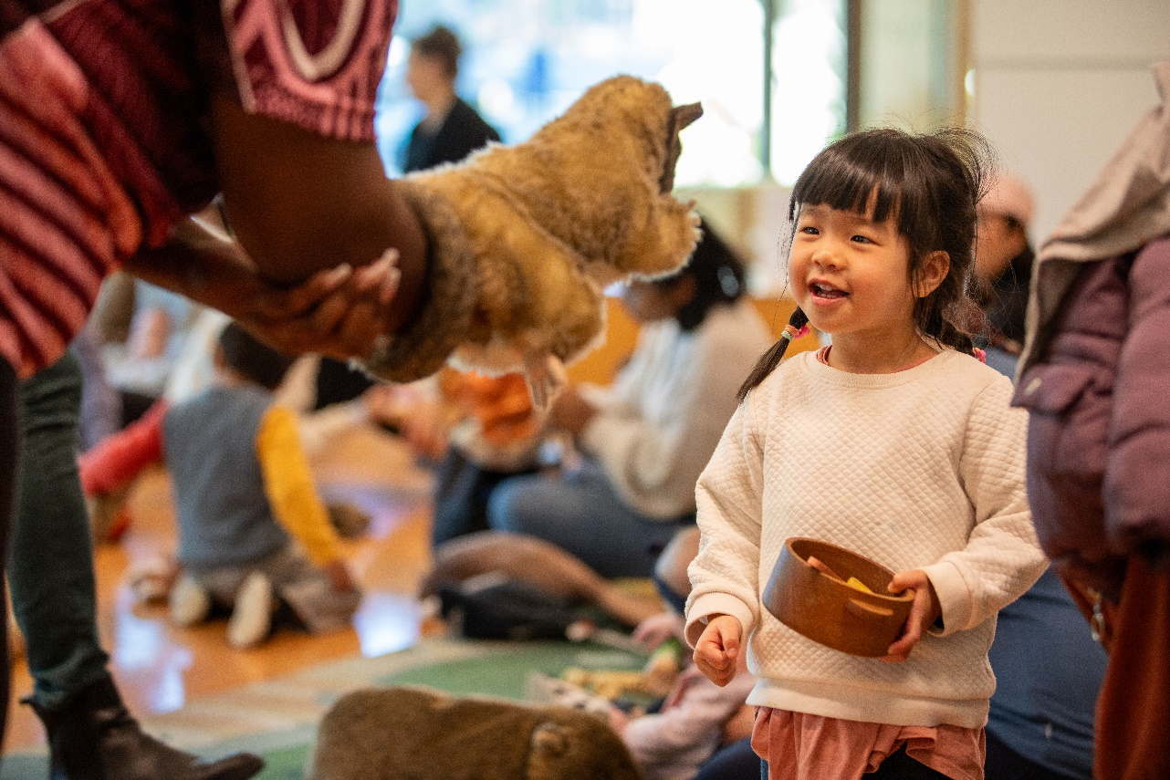

Someone wants to play with these toys!
I can take turns.
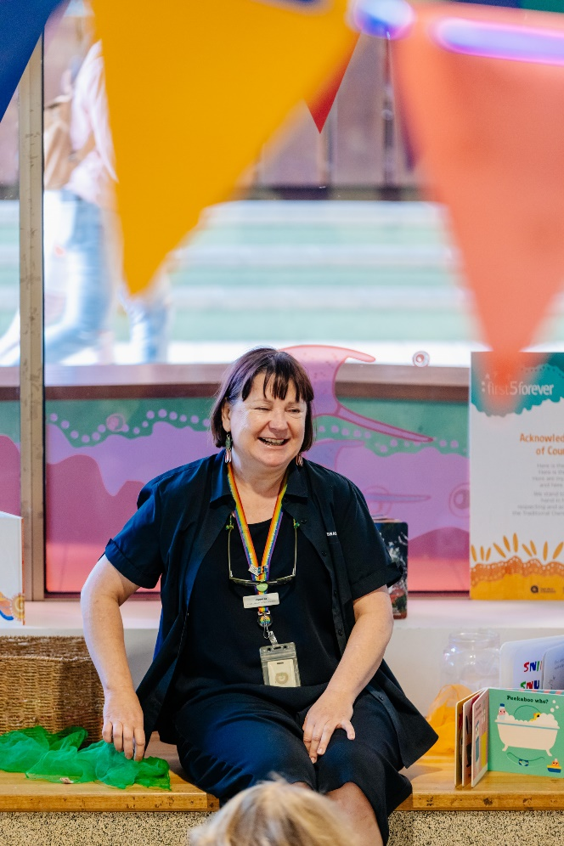
I can ask State Library staff for help if I can’t find my adult.
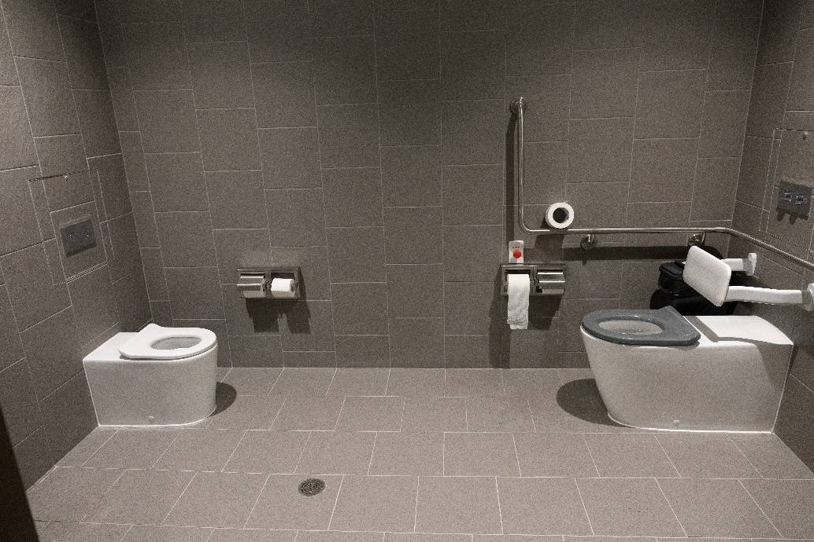
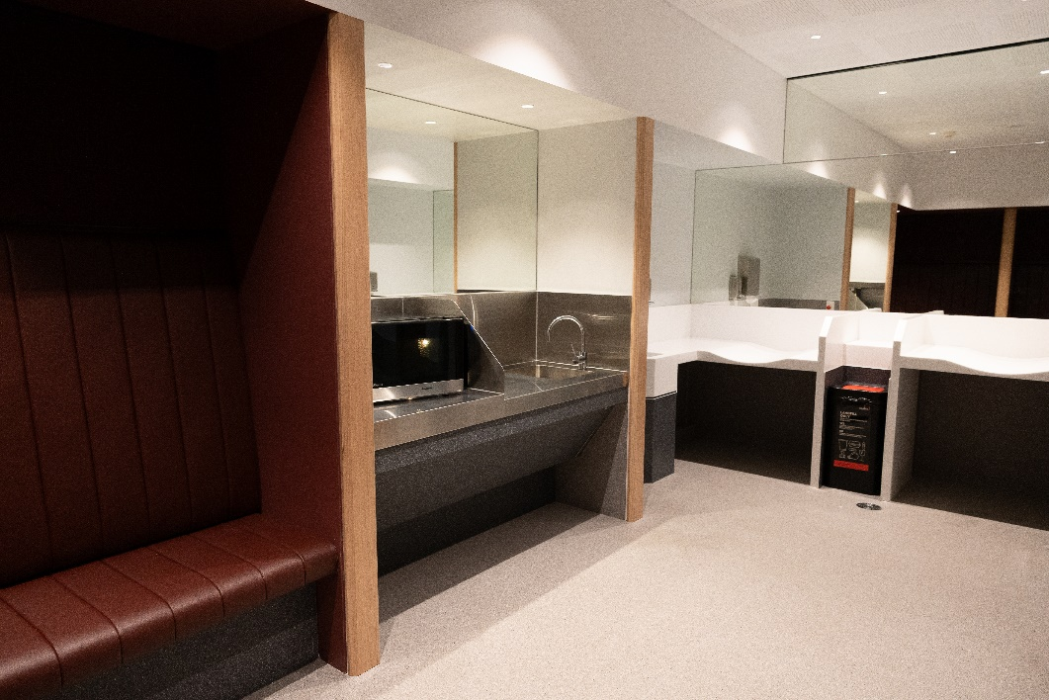

I can wash my hands in the Carers room.
We can go to the toilet here. We can heat food too.

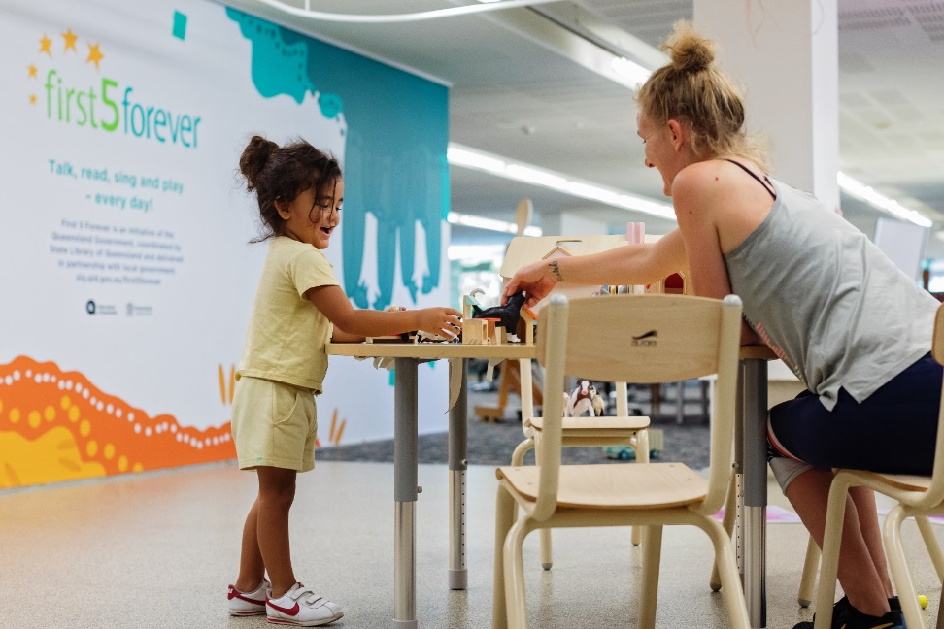
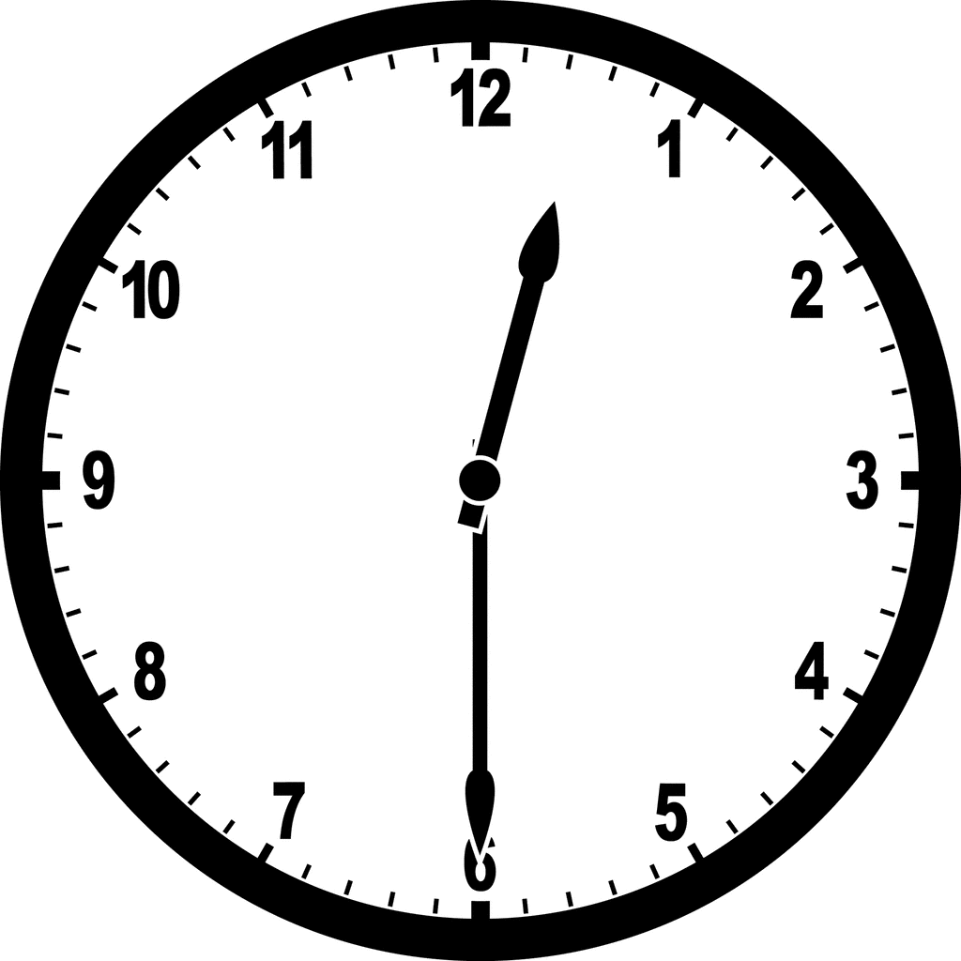

It is 12.30 pm. It is pack up time.

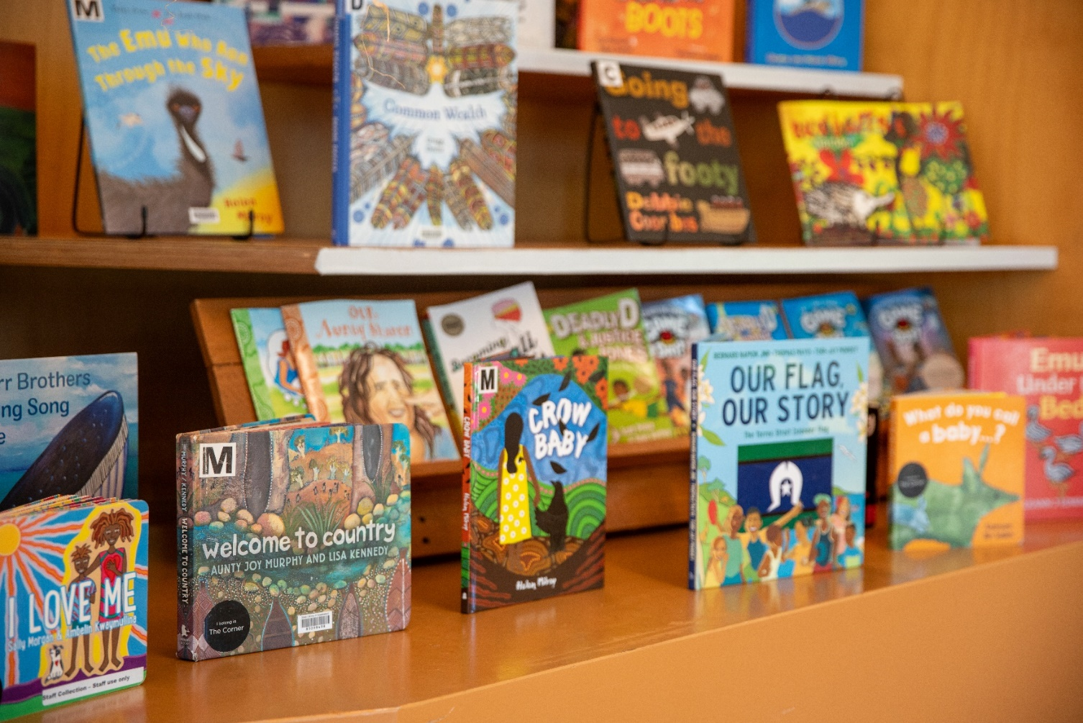
I put my library books away.
I can read them next time I am at the library.
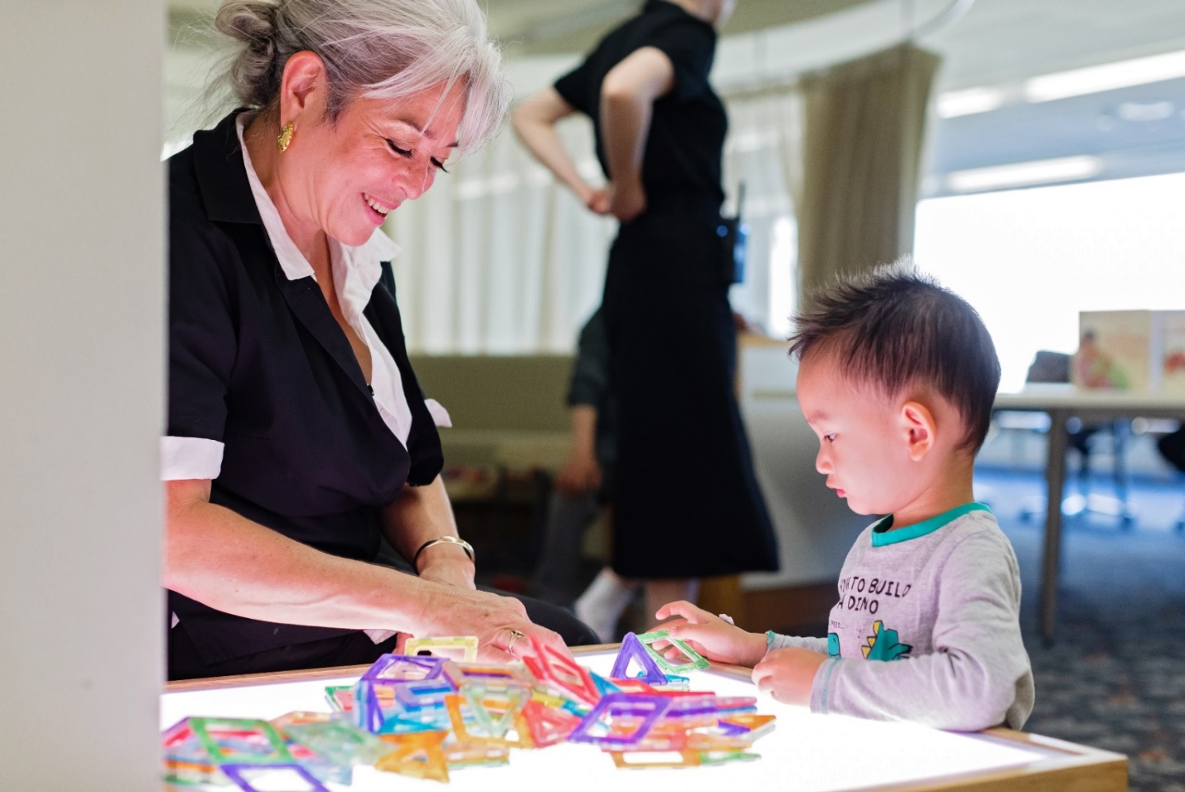
Staff put toys away.
We can play with them next time.
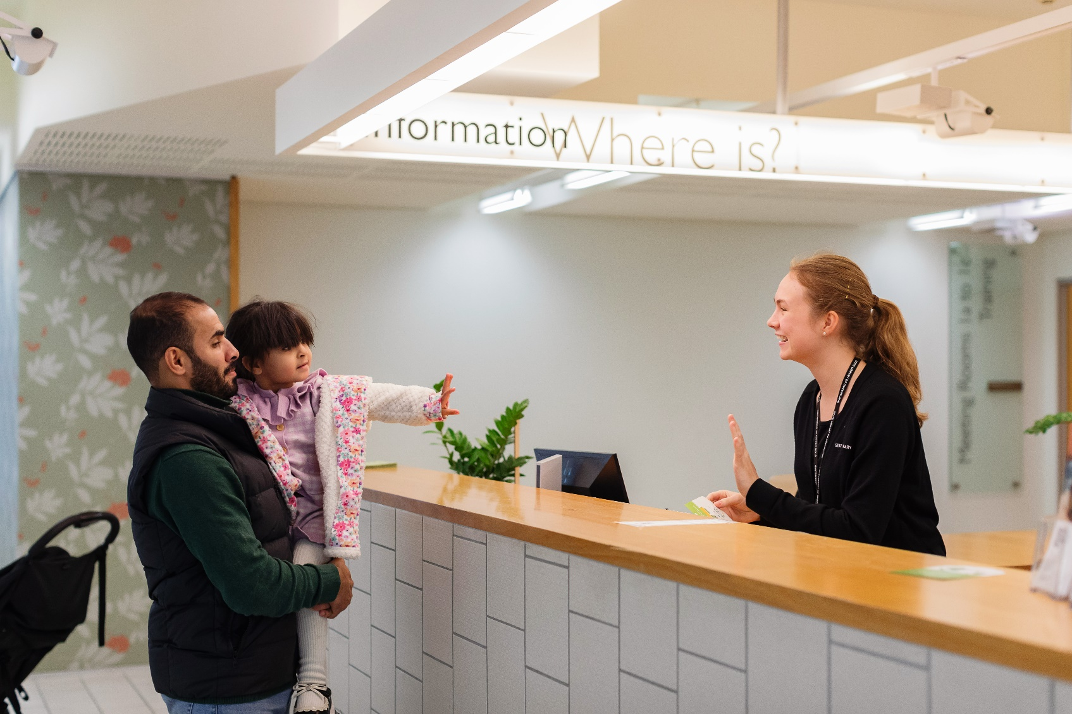

It is time to go now. I can come back another day.
Information for carers
It is your role to stay with and watch over the children in your care.
Programs run from 10am – 12.30pm every day in The Corner.
These programs are free to attend. No Bookings required.
You can come and go as you need.
You might need to book in to come to special programs. You can ask a staff member or check our website.
The Corner is open for free play and usually quietest from 12.30pm – 5pm.

Useful links

The Corner: The Corner | State Library of Queensland

Getting here: Getting here | State Library of Queensland

Access at the library: Access and inclusion | State Library of Queensland
Useful links continued

Food and Carers room: Food and facilities | State Library of Queensland

Opening hours: Opening hours | State Library of Queensland

With thanks to the following photographers who have supplied imagery to State Library of Queensland:

Joe Ruckli (page 2,5,8 9,11, 12, 16, 17, 19, 21)
Katie Bennett (page 3, 4, 7, 23, 25, 26)
Children’s Rights (page 6)
Shanella Majid (page 18)

