State Library of Queensland acknowledges the Traditional Owners of the land on which State Library is located. We pay respects to their Ancestors who came before them and to their Elders past, present and future. The location of State Library, on Kurilpa Point, was historically a significant meeting, gathering and sharing place for Aboriginal people. We also acknowledge the significant contributions made by the Australian South Sea Islander community to Queensland’s diverse history.

Plantation Voices
Emerging from the sugarcane farms of tropical Queensland to cut a path to freedom, the stories of Australian South Sea Islanders are steeped in strength and resilience.
Through never-before-seen original photographs, rare and restricted historical papers, and newly commissioned artworks, Plantation Voices repatriates the living history of the unknown names and faces of people tricked or kidnapped into servitude as cheap labour in Queensland’s cane fields.
More than 150 years later, the exhibition also charts the pathways of descendants in reclaiming their lost past and forging their identities into the future.
Through this free exhibition, State Library’s heritage collections give voice to the untold stories of a community that played a vital role in the shaping of our nation, and who fought so fiercely to call Australia home.

Learning Notes

How to use Plantation Voice Learning Notes
These learning notes have been designed to support educators to engage with State Library’s exhibition Plantation Voices and the collection items which give voice to the unique and rich stories of Australian South Sea Islanders. These notes are designed to live beyond the exhibition, as an entry point into the exhibition and a springboard to support the delivery of the Australian National Curriculum and Queensland Senior Syllabuses outcomes.
Plantation Voices learning notes link directly to a range of State Library collection items which can be used to scaffold learning experiences in the classroom and during your visit to State Library. More information on the exhibition and the collection items showcased can be found by visiting Plantation Voices on the State Library website.
Note that in reference material the terms South Sea Islanders and Pacific Islanders are used interchangeably.

Senior Years

History
Before coming to Plantation Voices, write a series of inquiry questions to help you investigate the history of Australian South Sea Islanders.
Working individually or in groups, research the following and discuss as a class:
- What was the impact of ‘blackbirding’ on the Australian Aboriginal population?
How did the Australian South Sea Islander community survive during and after deportation and how did the petition influence the opportunity to stay?

- As non-citizens of Australia, did Australian South Sea Islanders serve in the First or Second World War in Malaya, Korea and Vietnam?

English
Read Australian South Sea Islanders in WWI. Select one of the service men discussed in the post and write a short story about that person’s time in the war.

Art
Select one of the listed artworks as stimulus and respond to the following question:

- How did the artist manipulate media and techniques to communicate contemporary issues through the artwork?
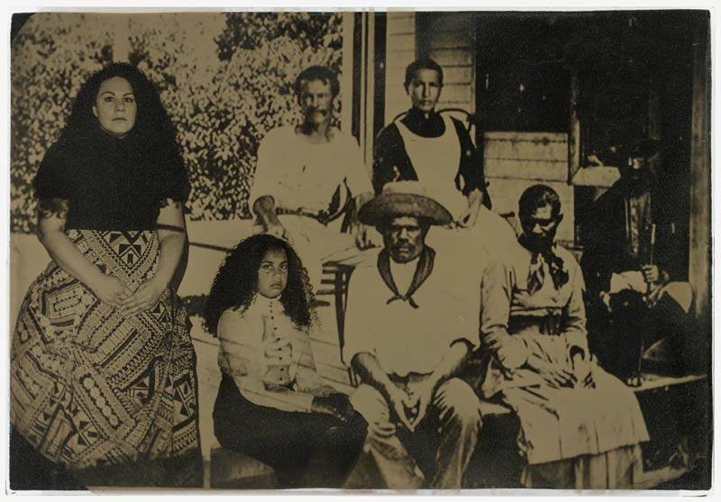
You will need to justify your viewpoint with analysis, interpretation and evaluation of the selected artwork through specified context/s.

- 31843 The Past is ahead, don't look back
Jasmine Togo-Brisby
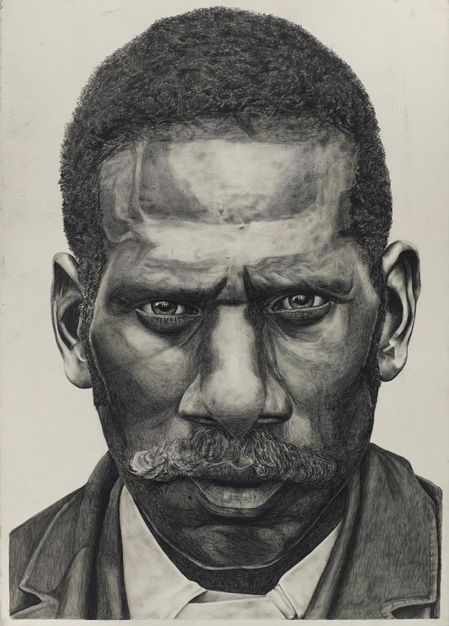

- 31872 Stop and Stare drawings
Dylan Mooney

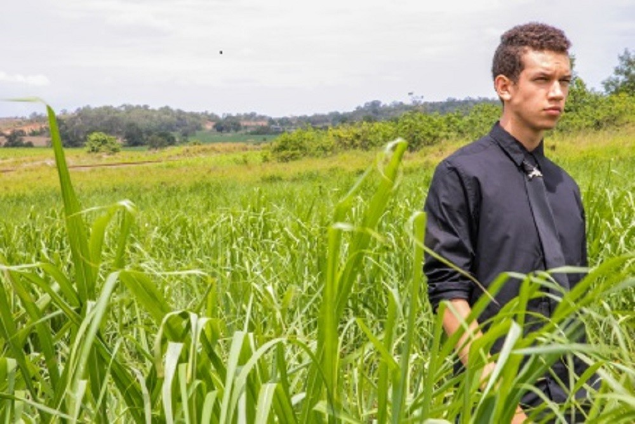

- 31842 25 years of Australian South Sea Islander National Recognition
LaVonne Bobongie

Appendix
One search – Australian South Sea Islanders
Australian South Sea Islander Blog
Australian South Sea Islanders historical photographs
Mal Meninga
The Old Place: Lot 71
Joskeleigh: A Place to Call Home
Reclaiming Kanaka Town: Recollections from Mr Nelville Willie digital story
Historypin: Images and experiences of the original South Sea Islanders and their descendants, the Australian South Sea Islanders.
31843 The Past is ahead, don't look back
31872 Stop and Stare drawings
31842 25 years of Australian South Sea Islander National Recognition

